Remember to keep our sick and shut-in members, as well as those who are hospitalized, lifted in prayer. Let’s continue to show love, compassion, and support through our prayers during this time. May God bring comfort, strength, healing, and peace to each of them and their families.
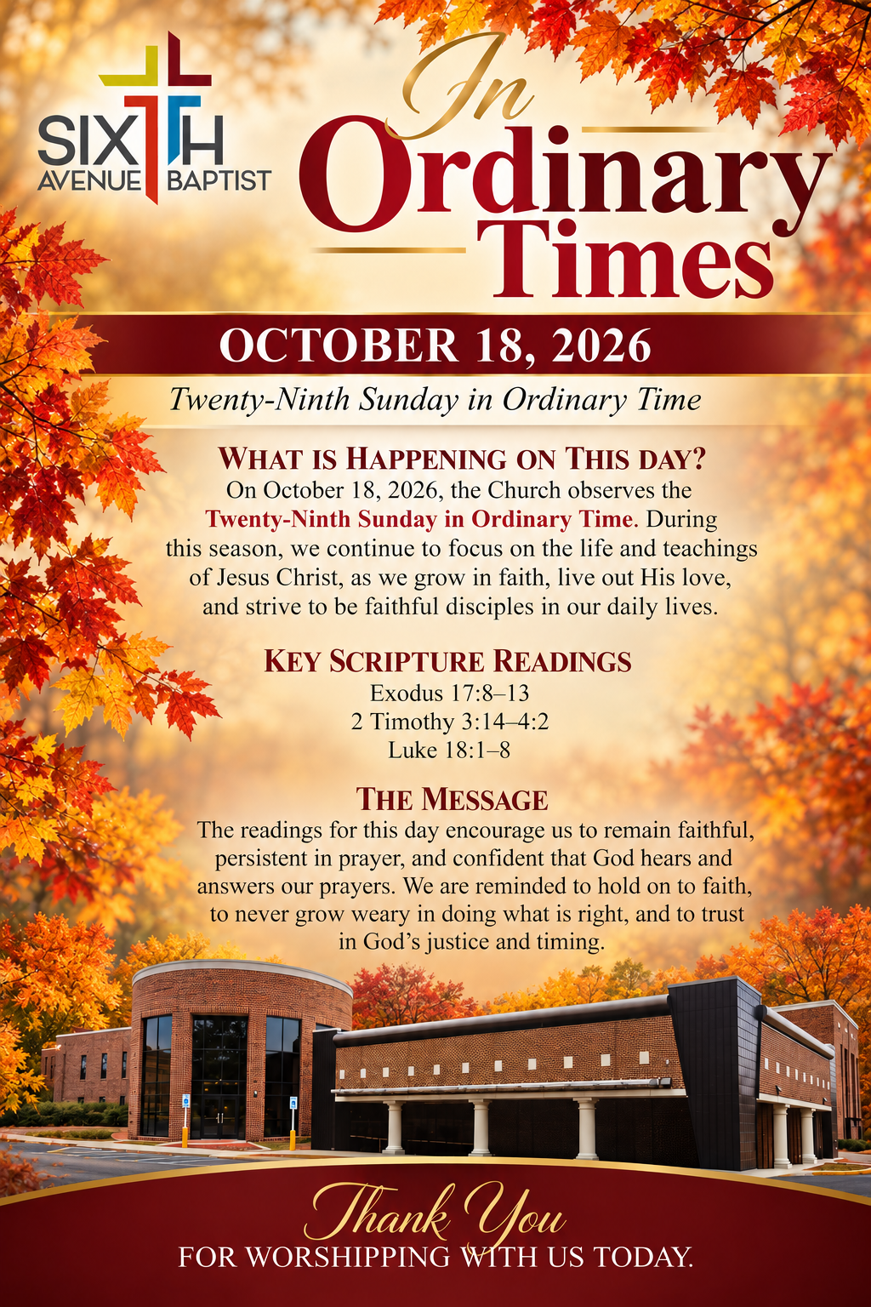
Annie Bush
Brenda Burns
Iretha Manning
Mary Blevins
Sharon Austin
Rosie Hayden
Elizabeth Hall
Deborah Witt
Roberta Hampton
Larry Foster
Delores Jackson
Ed Crenshaw Victor McDonald
Isaac Smith
Cheryl Lee
Estelle Jones

William Gladden
Anthony Means
Davetta B. White
Ira Cole
Gladys Craig
Joyce Osborn
Carol Teague
Tara Ransom
Lucille Reese
Ponzella Fuller
Annie Holt
Brenda Davis
Thomas Shaw
Helen Toney
Patrick Fuller

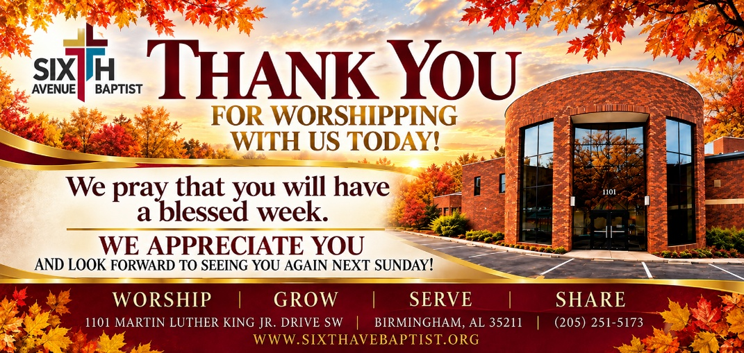
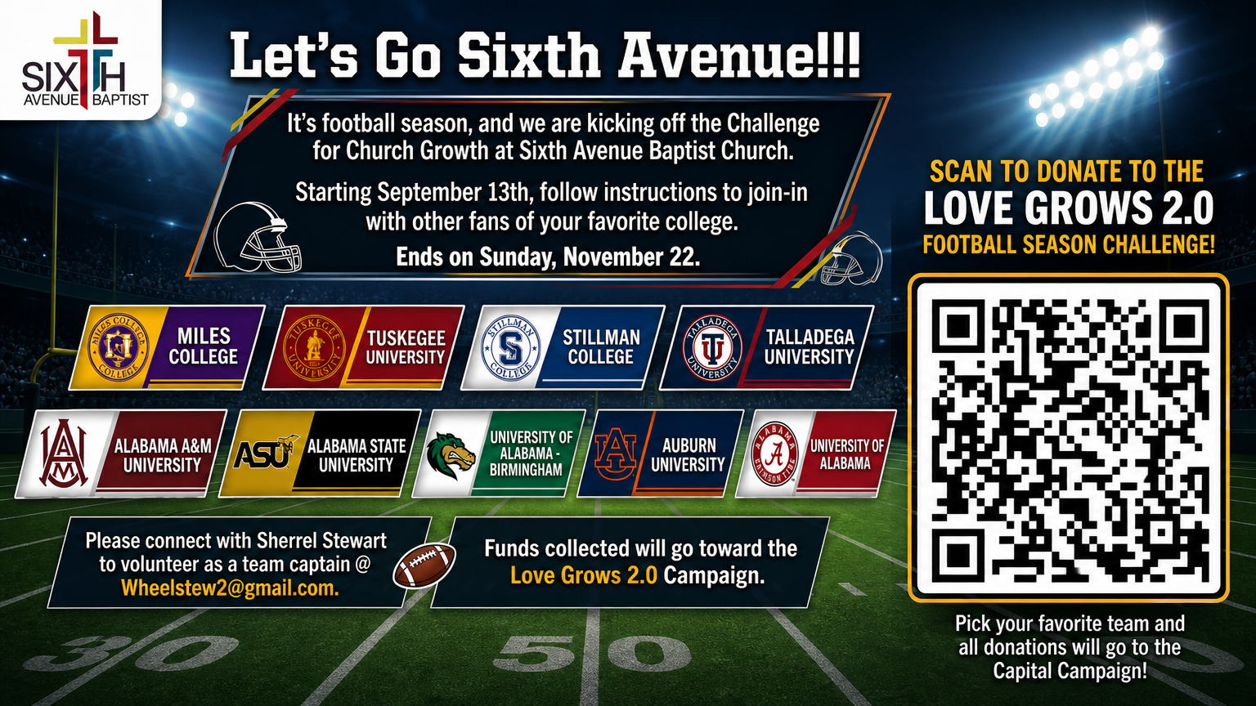
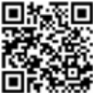
1101 Martin Luther King Jr. Dr. SW
Birmingham, Alabama 35211
205-251-5173(O) 205-715-0341 (F)
www.sixthavebaptist.com


Visitors Scan the QR Code
 Mondays Monday Morning Meditation (zoom) 7:15 am – 7:30 am
October 20th Bible Study (online & in- person) 6:00 p.m. Chapel
October 20th Bible Study (online & in-person) 6:00 pm Chapel & 136
October 21st Morning Bible Study (online & in-person) 11:00 a.m.
Chapel
October 21st Wednesday Prayer Meeting – Chapel 12:00 pm
October 21st Evening Classes (online & in-person) Boardroom
October 21st SABC Black History Curriculum 4:00 pm – 5:00 pm (Zoom)
October 21st Children & Youth Bible Study (Rm 120 - 111) 6:00 pm
October 22nd Bible Study (online only) 6:00 p.m.
October 25th Tailgate Sunday (immediately following Morning Worship)

The Challenge for Church Growth is open. Show your support for your favorite school and contribute to the Love Grows Capital Campaign. Simply scan the QR Code, select your school and contribute. Let’s Do This Sixth Avenue!!!

Song: I’m Blessed

Prayer: Rev. Carmone Owens

Prayer Response: We Offer Praise

Responsive Reading: 1 Thessalonians 1:1-10

Rev. Yolanda McMillan

Prayer in Groups

Hymn: Down at the Cross

Offertory Prayer: Dr. Rosevelt Morris, Sr.

Announcements

Song: Everybody Ought to Know

Spoken Word: Rev. Wendell H. Paris, Jr.

Hymn of Invitation: Just as I Am
Benediction

