Remember to keep our sick and shut-in members, as well as those who are hospitalized, lifted in prayer. Let’s continue to show love, compassion, and support through our prayers during this time. May God bring comfort, strength, healing, and peace to each of them and their families.
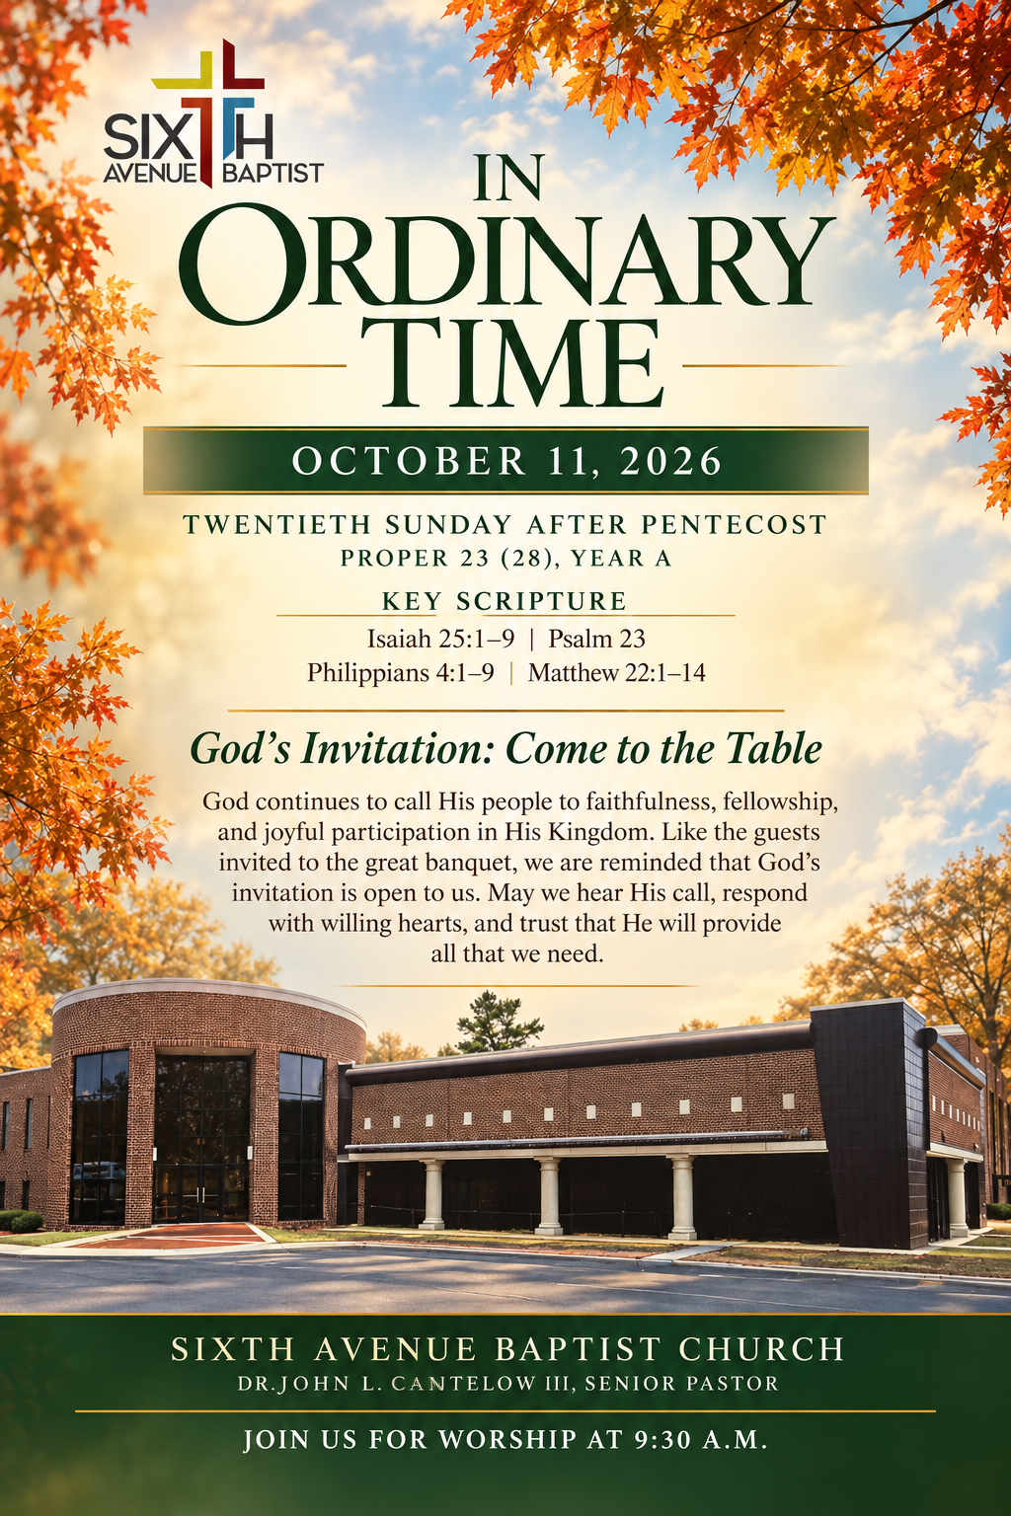
William Gladden
Anthony Means
Davetta B. White
Ira Cole
Gladys Craig
Joyce Osborn
Carol Teague
Tara Ransom
Lucille Reese
Ponzella Fuller
Annie Holt
Brenda Davis
Thomas Shaw
Helen Toney
Patrick Fuller

Cornelieus Easter
Annie Bush
Brenda Burns
Iretha Manning
Mary Blevins
Sharon Austin
Rosie Hayden
Elizabeth Hall
Deborah Witt
Roberta Hampton
Larry Foster
Delores Jackson
Ed Crenshaw Victor McDonald
Isaac Smith
Cheryl Lee
Estelle Jones

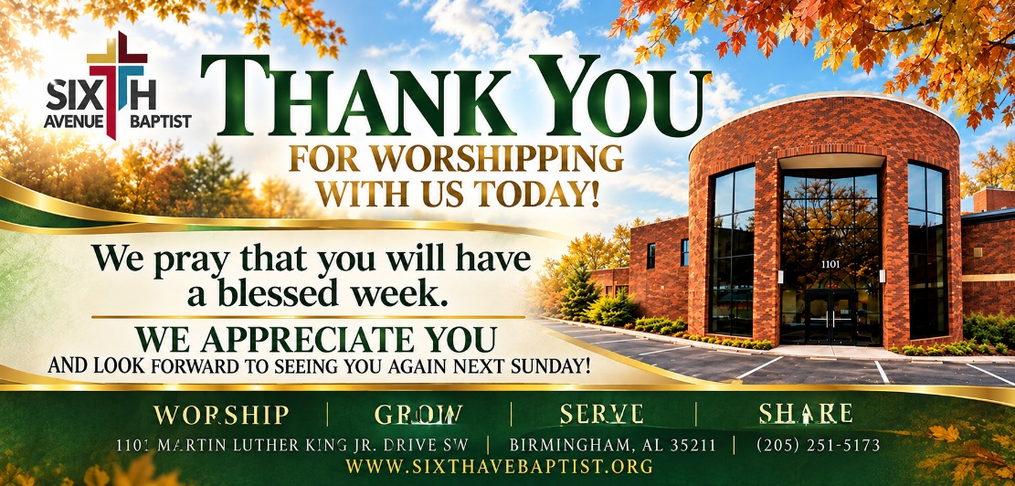
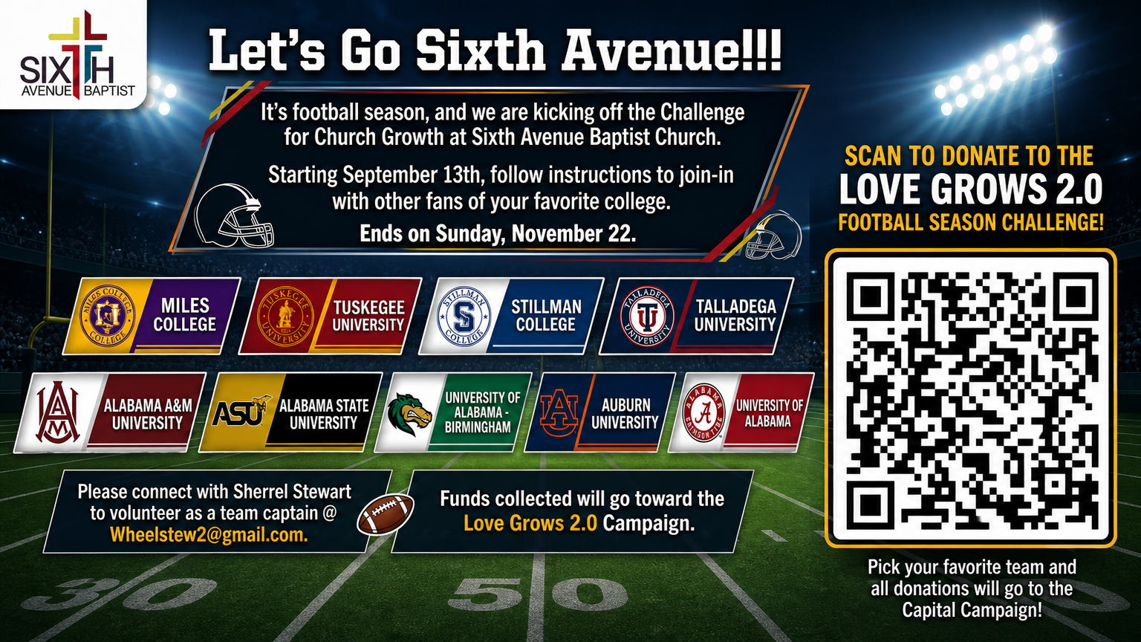

1101 Martin Luther King Jr. Dr. SW
Birmingham, Alabama 35211
205-251-5173(O) 205-715-0341 (F)
www.sixthavebaptist.com


Visitors Scan the QR Code
 Mondays Monday Morning Meditation (zoom) 7:15 am – 7:30 am
October 13th Bible Study (online & in- person) 6:00 p.m. Chapel
October 13th Bible Study (online & in-person) 6:00 pm Chapel & 136
October 14th Morning Bible Study (online & in-person) 11:00 a.m.
Chapel
October 14th Wednesday Prayer Meeting – Chapel 12:00 pm
October 14th Evening Classes (online & in-person) Boardroom
October 14th SABC Black History Curriculum 4:00 pm – 5:00 pm (Zoom)
October 14th Children & Youth Bible Study (Rm 120 - 111) 6:00 pm
October 15th Bible Study (online only) 6:00 p.m.
October 25th Tailgate Sunday (immediately following Morning Worship)

The Challenge for Church Growth is open. Show your support for your favorite school and contribute to the Love Grows Capital Campaign. Simply scan the QR Code, select your school and contribute. Let’s Do This Sixth Avenue!!!

Song: Collective Joy

Prayer: Nathan Warren

Prayer Response: Collective Joy

Responsive Reading: Philippians 4:1-9
Chase Holt

Hymn: Amazing Grace
Offertory Prayer
Liturgical Dancers
Announcements
Scripture Reading: Isaiah 25:1-9 ERV
John L. Cantelow III, Pastor

Song: Collective Joy
Spoken Word: Rev. Ralph Patterson
Trials, Tribulation & Testimony
Acts 26:19-29

Hymn of Invitation: Collective Joy
Benediction

