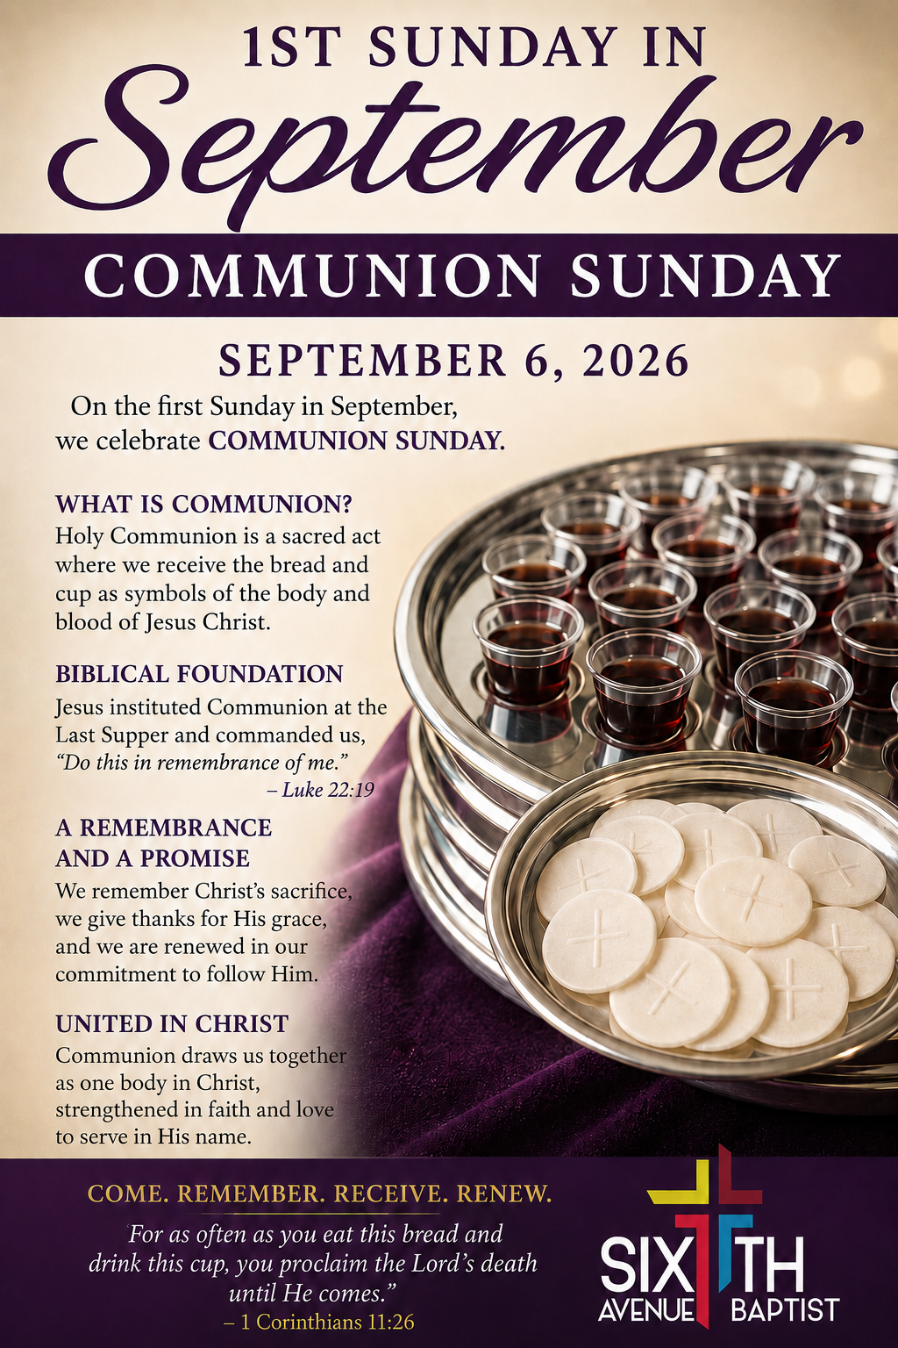
Remember to keep our sick and shut-in members, as well as those who are hospitalized, lifted in prayer. Let’s continue to show love, compassion, and support through our prayers during this time. May God bring comfort, strength, healing, and peace to each of them and their families.
Anthony Means
Davetta B. White
Ira Cole
Gladys Craig
Joyce Osborn
Carol Teague
Tara Ransom
Lucille Reese
Ponzella Fuller
Annie Holt
Brenda Davis
Thomas Shaw
Helen Toney
Patrick Fuller
Cheryl Lee
Estelle Jones
Isaac Smith
Victor McDonald
Larry Foster
Delores Jackson

Cornelieus Easter
Annie Bush
Brenda Burns
Iretha Manning
Mary Blevins
Sharon Austin
Joyce Croom
Rosie Hayden
Elizabeth Hall
Deborah Witt
Roberta Hampton
Ed Crenshaw

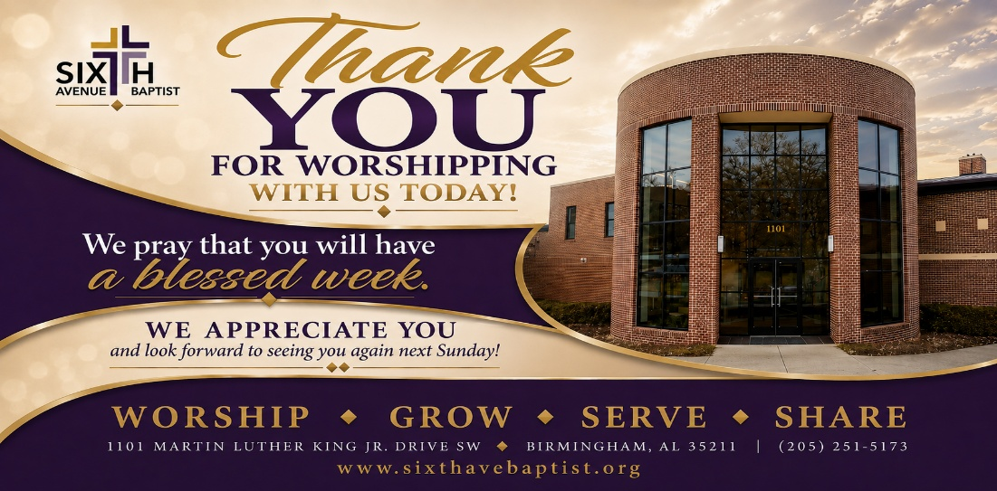

1101 Martin Luther King Jr. Dr. SW
Birmingham, Alabama 35211
205-251-5173(O) 205-715-0341 (F)
www.sixthavebaptist.com


 Mondays 7:00 am – 7:15 am Monday Morning Meditation (zoom)
September 8th Bible Study (online & in-person) 6:00 pm Chapel & 136
September 9th Morning Bible Study (online & in-person) 11:00 a.m. Chapel
September 9th Evening Classes (on-line & in-person) Boardroom
September 9th 12:00 am Wednesday Prayer Meeting – Chapel
September 9th SABC Black History Curriculum 4:00 pm – 5:00 pm (Zoom)
September 9th Children & Youth Bible Study (Rm 120 - 111) 6:00 pm
September 10th Bible Study (online only) 6:00 pm

Tutors needed Tuesday and Thursday, 5:30-6:30 pm.
Email dspencer@sixthavenuecdc.org to sign up and
help make a difference in a child's life.

Sixth Avenue Baptist Church
Alumni Family and Friends Initiative for
Debt Retirement
Sixth Avenue Baptist Church Capital Campaign is officially launching the Alumni Family and Friends Initiative for Debt Retirement! The ultimate mission is total debt retirement so we can fully release our financial resources to expand community outreach, strengthen youth programming, and accelerate our church's long-term mission.
How you can help today?
As you exit the sanctuary today, please stop by the capital campaign table in the vestibule. If you are a former member updating your information, or if you know a past member, please fill out one of our Alumni Contact Cards and drop it in the box. Or you may use the QR Code below to access and complete the form also see a new section about the Debt Retirement Campaign on our Facebook page and Church website.




Song: So Good

Prayer: Deacon Osborne Roy

Prayer Response: All in His Hands

Responsive Reading: Psalm 119:129 -140

Deacon BJ Thomas

Hymn: Because He Lives

Offertory Prayer: Deacon Alphra Johnson

Announcements

Song: My Worship is For Real

Spoken Word: Dr. Marvin Conner

Hymn of Invitation: Yes, Lord, Yes

Communion

Benediction

