Remember to keep our sick and shut-in members, as well as those who are hospitalized, lifted in prayer. Let’s continue to show love, compassion, and support through our prayers during this time. May God bring comfort, strength, healing, and peace to each of them and their families.
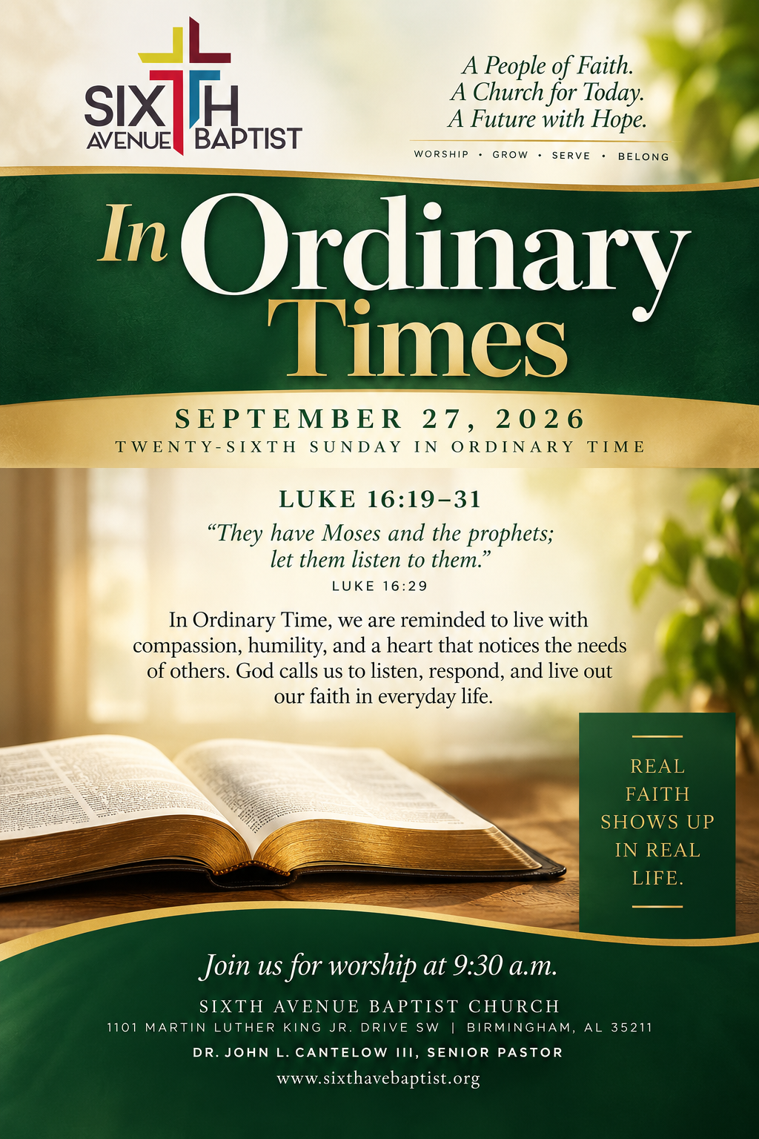
Dazzerine Picket
William Gladden
Anthony Means
Davetta B. White
Ira Cole
Gladys Craig
Joyce Osborn
Carol Teague
Tara Ransom
Lucille Reese
Ponzella Fuller
Annie Holt
Brenda Davis
Thomas Shaw
Helen Toney
Patrick Fuller

Cornelieus Easter
Annie Bush
Brenda Burns
Iretha Manning
Mary Blevins
Sharon Austin
Rosie Hayden
Elizabeth Hall
Deborah Witt
Roberta Hampton
Larry Foster
Delores Jackson
Ed Crenshaw Victor McDonald
Isaac Smith
Cheryl Lee
Estelle Jones

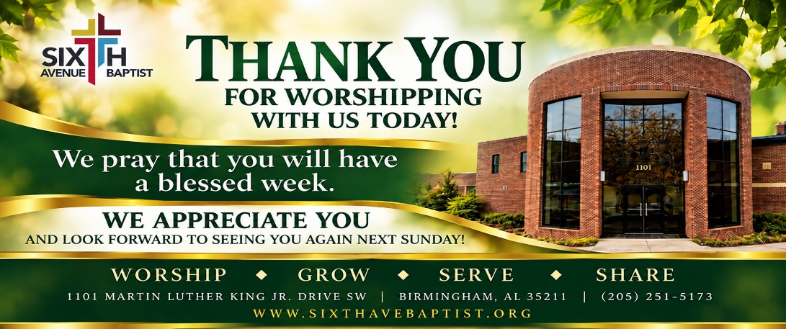

1101 Martin Luther King Jr. Dr. SW
Birmingham, Alabama 35211
205-251-5173(O) 205-715-0341 (F)
www.sixthavebaptist.com


 Mondays 7:15 am – 7:30 am Monday Morning Meditation (zoom)
September 29th Bible Study (online & in- person) 6:00 p.m. Chapel
September 29th Bible Study (online & in-person) 6:00 pm Chapel & 136
September 30th Morning Bible Study (online & in-person) 11:00 a.m.
Chapel
September 30th 12:00 pm Wednesday Prayer Meeting – (Chapel)
September 30th Evening Classes (online & in-person) Boardroom
September 30th SABC Black History Curriculum 4:00 pm – 5:00 pm (Zoom)
September 30th Children & Youth Bible Study (Rm 120 - 111) 6:00 pm
October 1st Bible Study (online only) 6:00 pm
October 25th Tailgate Sunday (immediately following worship)

(Today) September 27th Daniel and the Fiery Furnace 12:00 p.m.
(Premier Lux Theater Birmingham)

Visitors Scan the QR Code

Songs: I Love to Praise Him
Speak to My Heart

Prayer: Mr. Bernard Mays Jr.

Prayer Response: I’ve Seen Him Do It

Responsive Reading: Philippians 2:1-13
Mrs. Stephanie Mays

Hymn: Blessed Quietness

Offertory Prayer: Mrs. Monique Silas

Announcements

Song: I Speak Jesus

Spoken Word: Dr. John L. Cantelow III, Pastor

Hymn of Invitation: I Will Trust in the Lord

Benediction

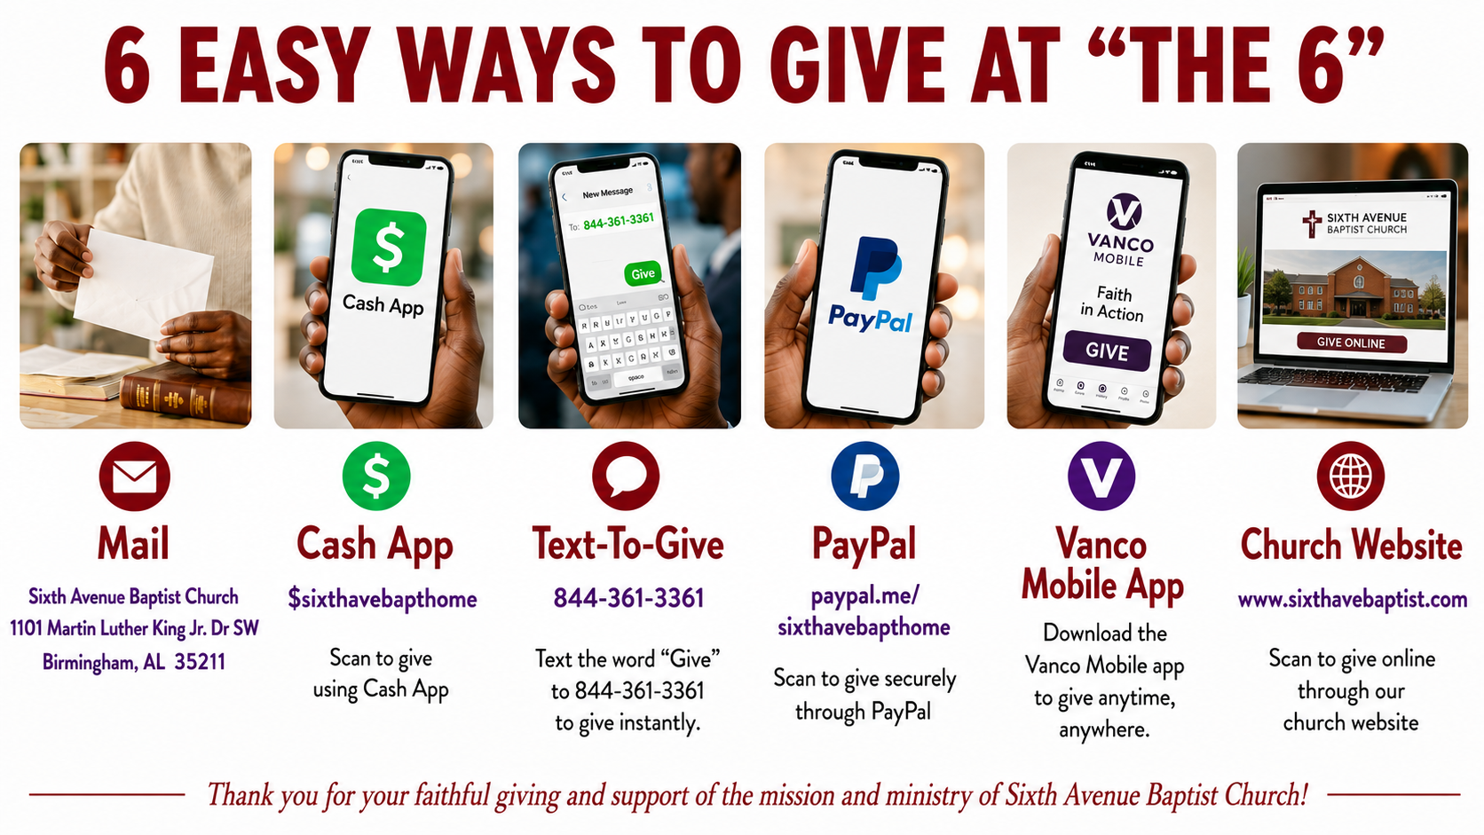

Sixth Avenue Baptist Church
Alumni Family and Friends Initiative for
Debt Retirement
Sixth Avenue Baptist Church Capital Campaign is officially launching the Alumni Family and Friends Initiative for Debt Retirement! The ultimate mission is total debt retirement so we can fully release our financial resources to expand community outreach, strengthen youth programming, and accelerate our church's long-term mission.
How you can help today?
As you exit the sanctuary today, please stop by the capital campaign table in the vestibule. If you are a former member updating your information, or if you know a past member, please fill out one of our Alumni Contact Cards and drop it in the box. Or you may use the QR Code below to access and complete the form also see a new section about the Debt Retirement Campaign on our Facebook page and Church website 

