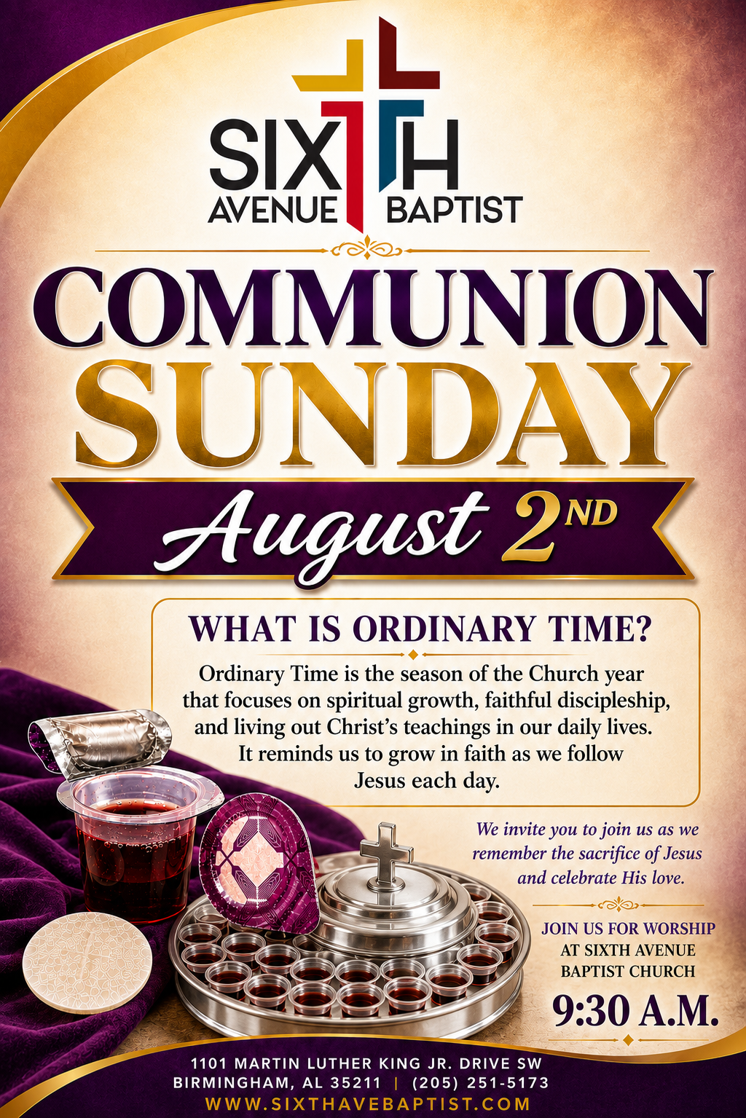
Remember to keep our sick and shut-in members, as well as those who are hospitalized, lifted in prayer. Let’s continue to show love, compassion, and support through our prayers during this time. May God bring comfort, strength, healing, and peace to each of them and their families.

Lawrence Davis, Jr.
Gladys Craig
Joyce Osborn
Carol Teague
Tara Ransom
Lucille Reese
Ponzella Fuller
Annie Holt
Brenda Davis
Thomas Shaw
Helen Toney
Patrick Fuller
Cheryl Lee
Estelle Jones
Isaac Smith
Victor McDonald
Larry Foster
Delores Jackson

Cornelieus Easter
Annie Bush
Brenda Burns
Iretha Manning
Mary Blevins
Sharon Austin
Joyce Croom
Willie C. Thomas
Rosie Hayden
Elizabeth Hall
Deborah Witt
Roberta Hampton
Ed Crenshaw

1101 Martin Luther King Jr. Dr. SW
Birmingham, Alabama 35211
205-251-5173(O) 205-715-0341 (F)
www.sixthavebaptist.com


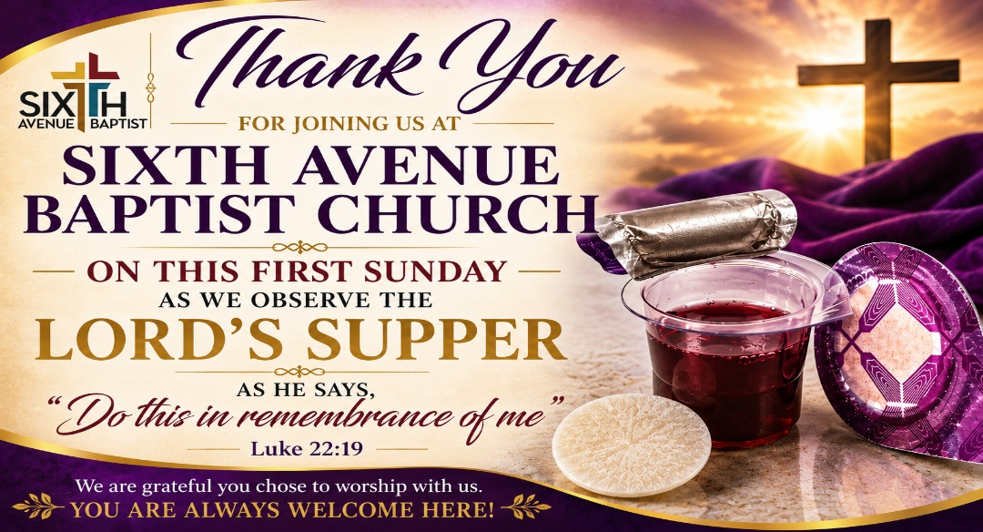
Mr. Travis Goodman

Songs: Let There Be Praise

Prayer: Deacon Chris Woods

Prayer Response: I Give Myself Away

Responsive Reading: Matthew 14:13-21

Deacon Herman Lumzy

Hymn: Nothing But the Blood of Jesus

Offertory Prayer: Deacon Leroy Jackson

Announcements

Song: There is a Fountain

Spoken Word: Dr. John L. Cantelow III, Pastor

Hymn of Invitation: Withholding Nothing

Communion

Benediction

Church Family, from time to time, the Administrative Staff of Sixth Avenue Baptist Church attempts to communicate important information and updates through emails, letters, and text messages. For us to keep our congregation informed and connected, it is essential that we maintain accurate and up-to-date contact information for each member of our church family.
With that in mind, we kindly ask that you take a moment to provide us with yours. You may scan to complete or email lkelly@sixthavebaptist.org
- Full Name
- Mailing Address
- Email Address
- Home Telephone Number
- Cell Phone Number
- Any other preferred means of contact
Your cooperation in helping us keep our records current is greatly appreciated and will help ensure that you receive important announcements, ministry updates, and other church communications in a timely manner.
The Administrative Staff sincerely appreciates your assistance and cooperation in this matter.

Mondays 7:00 am – 7:15 am Monday Morning Meditation (zoom)

August 5th 1 2:00pm Wednesday Prayer Meeting – Chapel

August 5th SABC Black History Curriculum 4:00p – 5:00p (Zoom)

August 11th Congregational Church Meeting – 6:00 p.m.

August 22nd Women on Mission 2026 Annual Conference
8:30 a.m.- 12:00 p.m. (Fellowship Hall)

Children & Youth
Nursery /Preschool: Every Sunday @ 9:30am, Ages 0- 4

Children’s Church: Every Sunday @ 9:30am, K-5th Grades

Collision Church: 1st & 3rd Sundays @ 9:30am, Middle & High School

Children & Youth Choir: Combined choir sings monthly

Preschool High School Ages


