George Craig, Sr.
Joyce Osborn
Carol Teague
Tara Ransom
Carl Exford
Lucille Reese
Keyuna Archie
Ponzella Fuller
Maggie Hawkins
Annie Holt
Mable Carey
Brenda Davis
Thomas Shaw
Gennie Hicks
Helen Toney
Patrick Fuller
Hazel Rosser
Cheryl Lee
Estelle Jones

Carolyn Johnson
Michael Maye
Sharon Austin
Joyce Croom
Clifford Strong
Willie Holmes
Brenda Burns
Mozella Pack
Willie C. Thomas
Rosie Hayden
Elizabeth Hall
Jackie Young
Deborah Witt
Edward Crenshaw
Larry Foster
Roberta Hampton
Isaac Smith
Charles Holt
Ralph Logan
Carolyn Johnson
Michael Maye
Sharon Austin
Joyce Croom
Clifford Strong
Willie Holmes
Brenda Burns
Mozella Pack
Willie C. Thomas
Rosie Hayden
Elizabeth Hall
Jackie Young
Deborah Witt
Edward Crenshaw
Larry Foster
Roberta Hampton
Isaac Smith
Charles Holt
Ralph Logan

George Craig, Sr.
Joyce Osborn
Carol Teague
Tara Ransom
Carl Exford
Lucille Reese
Keyuna Archie
Ponzella Fuller
Maggie Hawkins
Annie Holt
Mable Carey
Brenda Davis
Thomas Shaw
Gennie Hicks
Helen Toney
Patrick Fuller
Hazel Rosser
Cheryl Lee
Estelle Jones

Prayer
Sick & Shut- Ins:

Prayer
Sick & Shut-
Ins:

Prayer Opporties:
Sick & Shut- ins:
Cheryl Lee
Kim Booker-Graham
Alfred Bonner
Lillie McDowell
Derrick Hendrix
Henry Jones
Yolanda Holmes
Willie Barren
Estelle Jones
George Craig, Sr.
Joyce Osborn
Carol Teague
Tara Ransom
Cassandra Page
Helen Toney
Robert Jordan
Nadine Todd
Patrick Fuller
Hazel Rosser
Lester Reasor
- Our local & surrounding communities’ welfare
- Pray for gun violence to cease in our communities.
- Pray for those dealing w/healthcare concerns.
- Prayer for justice across the land & country.
- All people struggling w/ Covid-19, & Workers.
- President Joseph Biden & Vice-President Kamala Harris & Cabinet
- Local, State, & National Officials.
- Pastors, Church Ministries (Salvation, impact)
- Feeding the Hungry, The Homeless, unemployed
- The Education System: students, parents, admin.
- Unity, Justice, Economic Stability in our world.
- Pray for attentiveness to what truly matters.
- Pray for joy and a sense of humor.
- Pray for openness to the Holy Spirit guidance.
- Pray for the people in Ukraine & Russia.
- Pray for parent & child relationships.
- Pray for local businesses to strive.

Get Ready!
You’re invited to join us for our Fall Bible Study Classes beginning
Wednesday Mornings for Seniors – 11:00–11:45 AM
An uplifting time of fellowship and study designed especially for
Wednesday Evenings – Fall Bible Study Lineup
Grow in faith, connect with others, and dive deeper into God’s
Click below to see the full class lineup.
Upcoming Events
Upcoming Events

- Monday Morning Meditation every Monday at
7:15 a.m.

- Prayer Time, Wednesday at Noon

- SABC Black History Curriculum Wednesdays at
4pm Central time, Zoom Access ID:84840698215

Get Ready!
You’re invited to join us for our Fall Bible Study Classes beginning Wednesday, September 3rd.

- Wednesday Mornings for Seniors – 11:00–11:45 AM

- Wednesday Evenings – Fall Bible Study Grow in faith, connect with others, and dive deeper into God’s Word together. Various classes available.

- Monday Morning Meditation every Monday at
7:15 a.m.

- Prayer Time, Wednesday at Noon

- SABC Black History Curriculum Wednesdays at
4pm Central time, Zoom Access ID:84840698215

Get Ready!
You’re invited to join us for our Fall Bible Study Classes beginning Wednesday, September 3rd.

- Wednesday Mornings for Seniors – 11:00–11:45 AM

- Wednesday Evenings – Fall Bible Study Grow in faith, connect with others, and dive deeper into God’s Word together. Various classes available.
Upcoming Events
- Prayer Time, Wednesdays at Noon

- SABC Black History Curriculum Wednesdays at
4pm Central time, Zoom Access ID:84840698215

- June 29th today at 4pm - Men of Distinction Gospel Concert First Baptist Church, Trussville, Alabama.
- June 29th Family on the Fifth & Prayer Walk
Immediately

Up Coming Events:

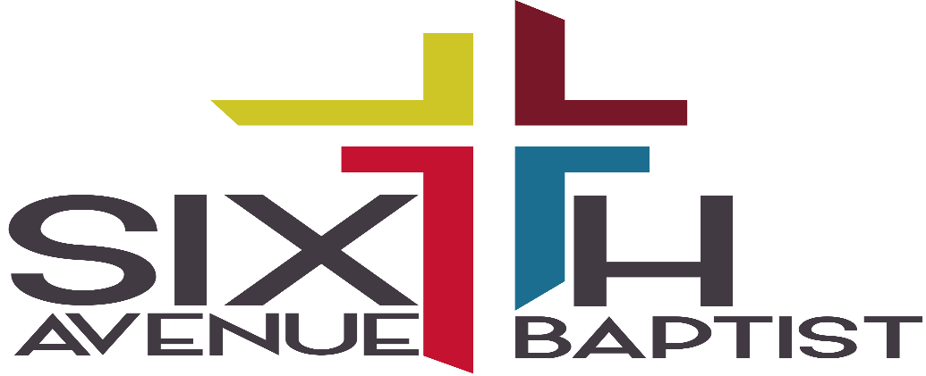


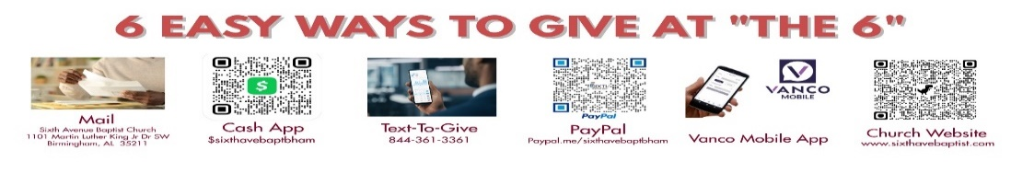
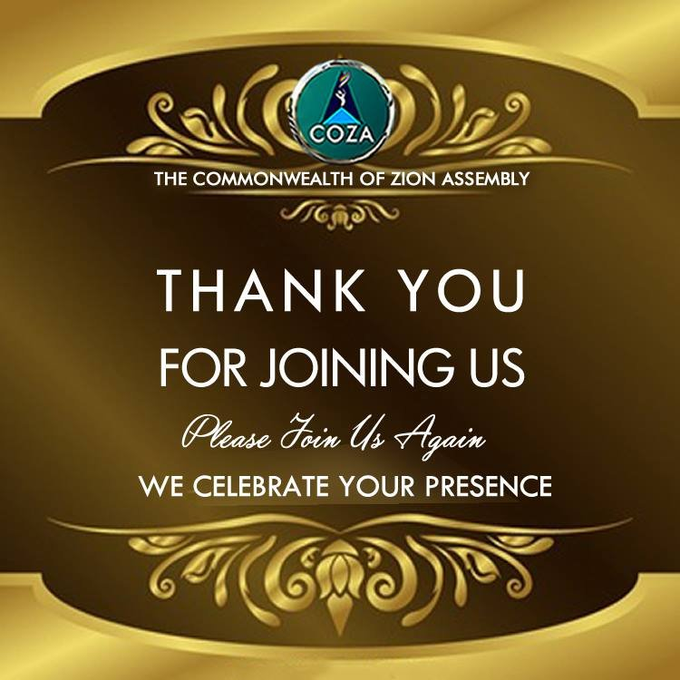
Visitors click here

August 31, 2025
Dr. John L. Cantelow III, Pastor

Song: O How Precious

Prayer: Tiye Jamison

Prayer Response: Glory

Responsive Reading: Hebrews 13:1-8; 15, 16

Karleigh Parker

Hymn: O I Want to See Him

Offertory Prayer: Dr. Rosevelt Morris, Sr.

Announcements

Song: Forever

Spoken Word: Rev. Wendell Paris, Jr.

Invitation to Discipleship: Available to You

Benediction
Visitors click here

.

August 31, 2025
Dr. John L. Cantelow III, Pastor

Song: O How Precious

Prayer: Tiye Jamison

Prayer Response: Glory

Responsive Reading: Hebrews 13:1-8; 15, 16

Karleigh Parker

Hymn: O I Want to See Him

Offertory Prayer: Dr. Rosevelt Morris, Sr.

Announcements

Song: Forever

Spoken Word: Rev. Wendell Paris, Jr.

Invitation to Discipleship: Available to You

Benediction

