George Craig, Sr.
Joyce Osborn
Carol Teague
Tara Ransom
Carl Exford
Lucille Reese
Keyuna Archie
Ponzella Fuller
Maggie Hawkins
Annie Holt
Mable Carey
Brenda Davis
Thomas Shaw
Gennie Hicks
Helen Toney
Patrick Fuller
Hazel Rosser
Cheryl Lee
Estelle Jones

George Craig, Sr.
Joyce Osborn
Carol Teague
Tara Ransom
Carl Exford
Lucille Reese
Keyuna Archie
Ponzella Fuller
Maggie Hawkins
Annie Holt
Mable Carey
Brenda Davis
Thomas Shaw
Gennie Hicks
Helen Toney
Patrick Fuller
Hazel Rosser
Cheryl Lee
Estelle Jones

Prayer Opportunities:
Sick & Shut- ins
Carolyn Johnson
Kate Clemon
Michael Maye
Sharon Austin
Joyce Croom
Clifford Strong
Willie Holmes
Brenda Burns
Mozella Pack
Horace Moore
Willie C. Thomas
Rosie Hayden
Elizabeth Hall
Jackie Young
Deborah Witt
Mary A. Farmer
Edward Crenshaw
Larry Foster
Roberta Hampton
Isaac Smith
Charles Holt
Ralph Logan

Prayer Opportunities:
Carolyn Johnson Sick & Shut- ins:
Kate Clemon
Michael Maye
Sharon Austin
Joyce Croom
Clifford Strong
Willie Holmes
Brenda Burns
Mozella Pack
Horace Moore
Willie C. Thomas
Rosie Hayden
Elizabeth Hall
Jackie Young
Deborah Witt
Mary A. Farmer
Edward Crenshaw
Larry Foster
Roberta Hampton
Isaac Smith
Charles Holt
Ralph Logan

- Monday Morning Meditation every Monday at
7:15 a.m.

- Prayer Time, Wednesday at Noon

- SABC Black History Curriculum Wednesdays at
4pm Central time, Zoom Access ID:84840698215

- Saturday, August 23, 2025 – 8:30 a.m. – 12:00 p.m.
Women on Mission 2025 Annual Conference held at
Sixth Avenue Baptist Church

Prayer Opporties:
Sick & Shut- ins:
Cheryl Lee
Kim Booker-Graham
Alfred Bonner
Lillie McDowell
Derrick Hendrix
Henry Jones
Yolanda Holmes
Willie Barren
Estelle Jones
George Craig, Sr.
Joyce Osborn
Carol Teague
Tara Ransom
Cassandra Page
Helen Toney
Robert Jordan
Nadine Todd
Patrick Fuller
Hazel Rosser
Lester Reasor
- Our local & surrounding communities’ welfare
- Pray for gun violence to cease in our communities.
- Pray for those dealing w/healthcare concerns.
- Prayer for justice across the land & country.
- All people struggling w/ Covid-19, & Workers.
- President Joseph Biden & Vice-President Kamala Harris & Cabinet
- Local, State, & National Officials.
- Pastors, Church Ministries (Salvation, impact)
- Feeding the Hungry, The Homeless, unemployed
- The Education System: students, parents, admin.
- Unity, Justice, Economic Stability in our world.
- Pray for attentiveness to what truly matters.
- Pray for joy and a sense of humor.
- Pray for openness to the Holy Spirit guidance.
- Pray for the people in Ukraine & Russia.
- Pray for parent & child relationships.
- Pray for local businesses to strive.

Upcoming Events
Upcoming Events
- Monday Morning Meditation every Monday at
7:15 a.m.

- Prayer Time, Wednesday at Noon

- SABC Black History Curriculum Wednesdays at
4pm Central time, Zoom Access ID:84840698215

- Saturday, August 23, 2025 – 8:30 a.m. – 12:00 p.m.
Women on Mission 2025 Annual Conference held at
Sixth Avenue Baptist Church

- Prayer Time, Wednesdays at Noon

- SABC Black History Curriculum Wednesdays at 4pm Central time, Zoom Access ID:84840698215

- June 26th, 6pm (Boardroom) Grief & Loss Ministry
In person and Zoom

- June 29th at 4pm - Men of Distinction Gospel Concert First Baptist Church, Trussville, Alabama.

- Prayer Time, Wednesdays at Noon

- SABC Black History Curriculum Wednesdays at
4pm Central time, Zoom Access ID:84840698215

- June 29th today at 4pm - Men of Distinction Gospel Concert First Baptist Church, Trussville, Alabama.
- June 29th Family on the Fifth & Prayer Walk
Immediately

Up Coming Events:



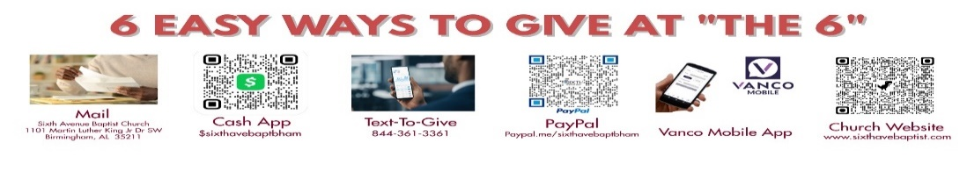
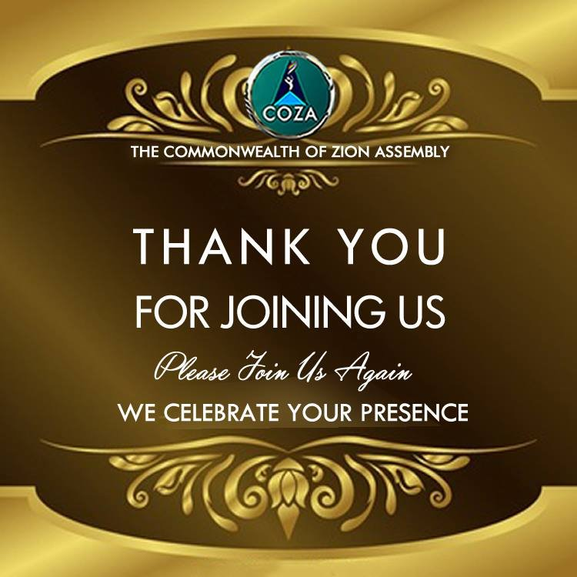

August 3, 2025
Dr. John L. Cantelow III, Pastor

Song: I Came to Magnify

Prayer: Deacon Reginald Reed

Prayer Response: Total Praise

Responsive Reading: Colossians 3:1-11

Deacon Zack Nelson

Hymn: Amazing Grace
Offertory Prayer: Deacon Richard Reid
Announcements
Praying for Our Schools

Song: Come Let Us Worship the Lord

Spoken Word: Dr. John L. Cantelow III

Invitation to Discipleship: I Know It Was the Blood
Communion: The Lord’s Supper

Benediction
Visitors click here
Visitors click here

.

August 3, 2025
Dr. John L. Cantelow III, Pastor

Song: I Came to Magnify

Prayer: Deacon Reginald Reed

Prayer Response: Total Praise

Responsive Reading: Colossians 3:1-11

Deacon Zack Nelson

Hymn: Amazing Grace
Offertory Prayer: Deacon Richard Reid
Announcements
Praying for Our Schools

Song: Come Let Us Worship the Lord

Spoken Word: Dr. John L. Cantelow III

Invitation to Discipleship: I Know It Was the Blood
Communion: The Lord’s Supper

Benediction

